Reinventing rural development: the urbanised society

A wonderful opportunity to join you in the conference, but I won’t miss the chance to put the central questions first.

The Commission has recently presented scenario’s for the Future of Europe. From Carrying on, just the single market, Europe of 2 or more speeds, doing less more efficiently, to doing much more together. Tell me where to go?

Because in this discussion we need to show what regions can do and how regions can bring added value to Europe and how Europe can be of added value for the regions. In this way we will end up with a scenario that is beneficial for the regions. An excellent example is the region where we are today: the Brabantse Kempen Region.

Last year the Dutch Kempen Region has been named by the Intelligent Community Forum (ICF) one of the twenty-one smartest regions in the world. Something to be proud of! This region is one of the “example regions” for building a new model for rural development by cooperating through the golden triangle of government, entrepreneurs and education, the triple helix, and by putting innovation and entrepreneurship in the centre.

There are 5 points that I want to emphasize:

1. What is the power behind your cooperation in the region? Is it legislation? No! Is it just a public initiative? No!

It is the wish of very different sectors to come together and build an excellent region. Now the question for many regions seems to be “are we the best”? A good question in itself, but only if you slightly adjust it to “are we the best in a particular field”? The Dutch Kempen Region qualified themselves in digital innovation, especially through establishing a fast internet connection and expanding the many internet applications. This creates opportunities and adds to increased quality of life in and vitality of the region. You are a winner in this field and can be an example of the followers in digital innovation. You are a leader now, and luckily you have many followers present here.

2. This leads me to one of the key notions of regional policy today: “smart specialisation”. In current regional policy, since 2014, every region needs to set up a smart specialisation strategy before it can receive money from the European Structural and Investment Funds. It is a so-called ex-ante conditionality. The idea behind the innovation policy of smart specialisation is to choose your focus: be a frontrunner in some areas and be a follower in others. The next step in that context is interregional cooperation: working together with other regions. Regions should always look at the question “where are partners”? As it takes 2 to tango.

It is all about connecting.

In that context it is important to keep in mind that the EU agenda is still in a process of developing. Many regions are inward looking (nose down). But a greater added value is in cooperation, sharing knowledge with other regions. A year ago the Agrifood platform did not exist yet, but after Commissioner Cretu’s visit to the Netherlands she saw the importance of this sector and the need for regions to connect. Brabant became one of the leading partners in the European Agrifood sector that has started last month.

3. For the last decade there have been more and more initiative focusing on the link between urban regions and rural regions. It has led some 10 years ago already to amongst others a pilot project on RURBAN which analysed territorial partnerships for towns/cities and rural areas to achieve better cooperation. But also to the PURPLE, Peri-urban regions platform Europe, where such regions work together to maximise the advantages of their location in proximity to large cities while minimising the disadvantageous impacts.

For rural regions like the Kempen technological development and digital innovation can mean that the link to urban regions is closer than ever. Although location can be important when it comes to for example employment, economic development etc, digital innovations like the roll out of 4G and 5G networks to the rural areas, location becomes less important. Being close is no longer the main thing. Focus and specialisation is what matters more than ever.

A special dimension is brought by the metropolitan areas in the EU. France merged its regions and gave their cities the status of metropoles. In this slipstream the region of Eindhoven / Kempen has developed its cooperation in this direction. They heavily knock on the EU door for a specific support scheme in the post 2020 period.

4. But there is more to it. Just excelling in fundamental knowledge will not bring you prosperity, growth and jobs in the end. It should go hand in hand with innovation, followed by production. Only this combination will lead to an increase in prosperity levels. It is about knowledge and production. Going down the whole chain: from excellent research, to innovation, to production, to export and growth in GDP.
This region understands this. The export numbers are high for the areas in which the region excels. The main export areas (based on numbers from 2014) are the chemical industry, Agrifood and metal industry.

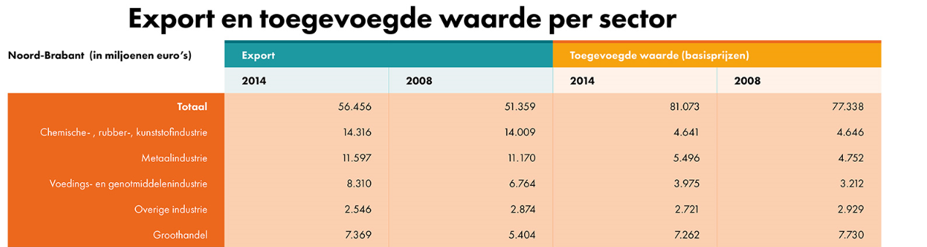

We have many regions in Europe that don’t go down this complete chain. Greece hardly exports anything. Their breakdown didn’t come out of the blue.

5. I want to finish with emphasizing the importance of communicating on great examples like the Dutch Kempen region.

I already mentioned in the beginning of my speech that there is the feeling that EU regional development policy is underperforming in branding. There is a serious hesitation in the appreciation of the EU policy. There are hardly any positive reactions on good projects in regions and cities. And the risk is out of sight is out of mind.

We must reboot our methods of communication. For this reason I launched a campaign to raise more awareness of EU investment and to provide citizens with examples of the EU’s added value and its positive contributions. I want to do this with you: working together and sharing what can be achieved. I want to make projects like yours shine!

Juncker launched his white book. I think we have to rebuild Europe with bottom-up commitments. Not just regulation or public responsibilities, but a shared participation in the EU project. There is a third way forward. We started with reinventing rural development and the link to the urbanised society with the Pact of Amsterdam during the Dutch presidency. It offers the possibilities to go straight to the European Commission with your project. It is a direct bottom-up way of working. It also offers cities the possibilities to direclty influence policy and legislation through the action plans. It revalidates what we are doing together at local, regional, national and EU level. It is regions that you that path the way for this new way forward.

